**Report for IQR:**

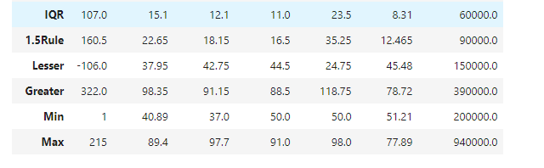

**Summary of the Placement Dataset Analysis**

We analyzed several key statistics from the placement dataset, focusing on the Interquartile Range (IQR), the 1.5 Rule (a method for identifying outliers), and the minimum and maximum values for various attributes.

1. Interquartile Range (IQR):
   * This measures the spread of the middle 50% of the data. For example, the IQR for one of the attributes is 107.0, meaning there's a moderate variation in the middle data points.
2. 1.5 Rule:
   * This rule helps us identify outliers by extending 1.5 times the IQR beyond the first and third quartiles. For instance, using this rule, values greater than 322.0 or less than -106.0 could be considered outliers.
3. Lesser and Greater Values:
   * These represent the lower and upper bounds calculated using the 1.5 Rule. If a value is below the "Lesser" bound or above the "Greater" bound, it's likely an outlier.
4. Minimum and Maximum Values:
   * The minimum value observed in the dataset is 1, and the maximum is 940,000. These values indicate the range of data we're working with.

**Overall Summary:**

The dataset shows a wide range of values, with some potential outliers identified using the 1.5 Rule. Understanding the IQR and outliers will help us make better decisions in analyzing the placement data.

**Top of Form**

**Bottom of Form**

Top of Form

Bottom of Form